The following are excerpts of text from the Banner Advancement 8.5.1 Release Guide. This is when gift integration was originally introduced for the Banner Advancement Connector. This release it only supported one-time gifts. Release 8.6.1 (June 2013) introduced support for perpetual and recurring gifts for the Banner Advancement Connector.
The highlighted fields below are the six ‘custom’ fields that Banner Advancement supports pulling over for gifts, in addition to the standard fields provided by iModules in the giving web services. These will need to be set-up as instance fields on the iModules side. Banner users are familiar with what these fields represent in the Banner System.
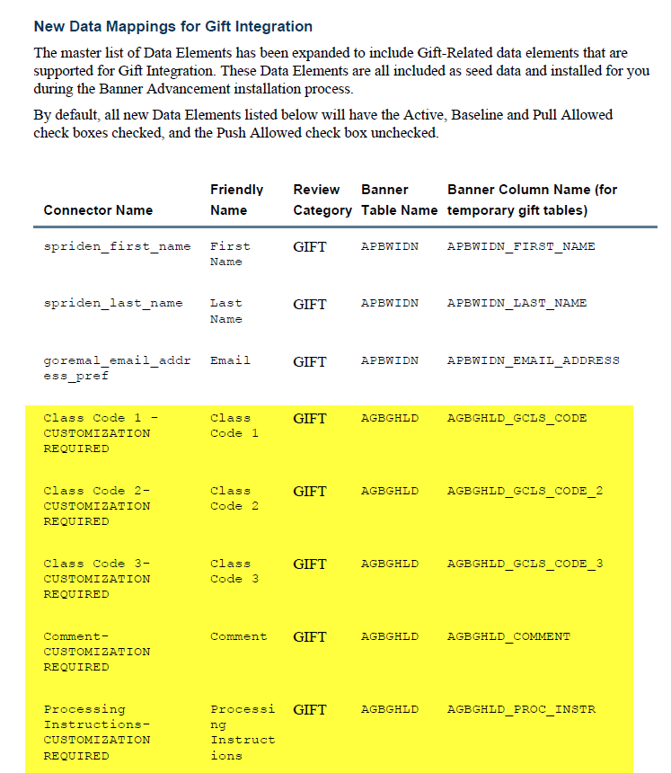
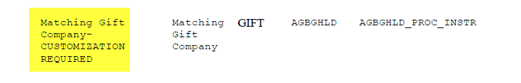
Here is additional information we have provided in this document regarding the correct set-up of Designations to ensure that they can be properly translated to Banner designations when the gift pull is performed. All of this information is also in the Banner Advancement DataLoad/Extract Handbook so Banner customers have a lot of documentation at their disposal.
